**5. Multicollinearity**

A topic specific to multiple regression models is multicollinearity (collinearity). Recall the assumption that the rank of ***X*** is equal to *k\**. That is, the *k* columns of matrix ***X*** (independent variables) are linearly independent from each other: The violation of this assumption is called **perfect/exact** multicollinearity, i.e. existence of linear relationships among the *x*-variables: for constant values  not all equal to zero. The implication is that ***X*** and similarlyare singular anddoes not exist. Hence, the LS estimator is not defined.

Perfect multicollinearity can rarely happen by chance in a sample, but may be incorporated by a wrong design. On the other hand, in a multiple regression model two or more independent variables may be highly correlated with each other. This phenomenon which is referred to as **imperfect/near** multicollinearity is what we study here. Note that in designed experiments with multiple independent variables, researchers usually choose the variables so that there is no multicollinearity. In observational studies, however, it is nearly always the case that the independent variables will be correlated. The question is how much the model can **tolerate** it.

**Sources of Multicollinearity**

There are various sources for multicollinearity.

* Data collection (sampling) method. For example, in the data collection phase an investigator may have drawn the data from such a narrow subspace of the independent variables that multicollinearity appears.
* Physical constraints, such as design limits, may also impact the range of some of these independent variables.
* Model specification such as too many higher-ordered terms/interactions and outliers can lead to collinearity.

When there is no multicollinearity, the effects of the individual predictors can be estimated independently of each other. When multicollinearity is present, the estimated coefficients are correlated (confounding) with each other.

* Clearly, rank of ***X*** is not equal to *k* if (micronumerosity), but we can rule out this case.

**Consequences of Multicollinearity**

* The LS estimators of remain **BLUE** as (near) multicollinearity does not violates the classical assumptions. But they have large variances and covariances, making the estimation imprecise.
* Inflated standard errors of the regression coefficient estimates, wider CI’s, deflated t-tests for significance testing, leads to false non-significance of coefficients and degradation of model predictability.
* Despite insignificance of many coefficients, the *R*2can be very high.

**Large Variance-Covariance**

To show this ramification, consider a model with two regressors,, for which the variances and covariance of estimates are defined as:



where  is the Pearson’s correlation coefficient betweenand. The degree of inflated variances and collinearity can typically be demonstrated by the following graph.

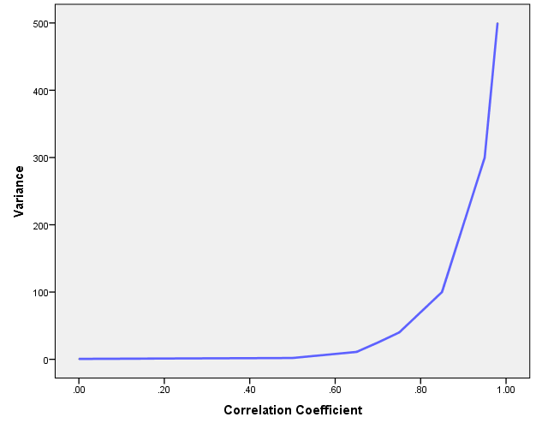

**Detecting Multicollinearity**

We introduce three primary ways for detecting multicollinearity.

**Method 1: Pairwise (Matrix) Scatterplots and Correlation**

We can visually inspect the data by doing pairwise scatterplots of the independent variables. So if you have (*k* – 1) independent variables, then you should inspect all  pairwise scatterplots together with the matrix of correlation coefficients, looking for any plots/values that seem to indicate a linear relationship between pairs of independent variables (*simple*/*zero-order*) correlation.

The problem with this criterion is that although high zero-order correlation may suggest collinearity the converse is not necessarily true. That is to say high zero-order correlations are a *sufficient* condition and not a *necessary* condition. For this reason, inspecting *partial* and *part* coefficients is also suggested.

**A Note on Part and Partial Correlation**

We define these concepts in the context of a two-regressor linear regression.



The generalisation to the higher cases is straightforward.

1. **Zero-order correlation:** These are (simple) correlation coefficients between the three variables: . Notice that , for example, is supposed to measure the linear association between y and **, but that is contaminated by the presence of **in the model.
2. **Partial Correlation:** The correlation between the dependent variable and an independent variable when the linear effects of the other independent variables in the model have been removed from both:

, the partial correlation between y and **, holding **constant.

, the partial correlation between *y* and **, holding **constant.

, the partial correlation between ** and **, holding *y* constant.

These are also called the *first-order* correlation coefficients. (Therefore,  is the *second-order* correlation coefficient, and so on.)

1. **Part Correlation:** Sometimes called the *semi-partial* correlation, is the correlation between the dependent variable and an independent variable when the linear effects of the other independent variables in the model have been removed from the independent variable. It is related to the change in when a variable is added to an equation.





* The more “tolerant” a variable is (i.e. the less highly correlated it is with the other regressors), the greater its unique contribution to *R*2 will be.
* Once one variable is added or removed from an equation, all the other semi-partial correlations can change. The semi-partial correlations only tell you about changes to *R*2 for one variable at a time.
* Semi-partial correlations are used in “Stepwise Procedures” which will be discussed later in the course

**Method 2: Variance Inflation Factor**

To use a measure of multicollinearity called the variance inflation factor (*VIF*). This is defined as:



where  is the coefficient of determination obtained by regressing on the remaining independent variables. A common rule of thumb is that if , then there is no multicollinearity, if  then there is possibly some moderate multicollinearity and if  then there is a strong indication of a collinearity problem. Sometimes, the tolerance is also reported. The tolerance is simply the inverse of the *VIF*.

**Method 3: Eigenvalue Methods**

The third method for identifying potential multicollinearity concerns a variety of measures using eigenvalues and eigenvectors.

Recall that multicollinearity occurs when linear combinations of some of the columns in the ***X*** matrix equal zero, or nearly zero. Geometrically this occurs when at least one dimension of the ***X***-space has very little dispersion (shown in the left graph below). When an independent variable has limited dispersion, its column in the ***X*** matrix will almost be a multiple of a vector of ones, with the result that the variable will be nearly collinear with the column for the intercept.



The presence of collinearity is detected by *singular decomposition* of ***X*** or the *eigenanalysis* of.

A value λ is called the eigenvalue of the correlation matrix  if there is a nonzero vector ***z*** such that . The nonzero vector ***z*** is called the *eigenvector*.

A set of eigenvalues (λs) of relatively equal magnitudes indicates little multicollinearity, while a wide variation in magnitudes indicates severe multicollinearity. Therefore, the ratio of the eigenvalues can be useful for examining multicollinearity. More formally, a measure of the overall multicollinearity of the variables can be obtained by computing what is called the **condition index** of the correlation matrix and is defined as . Obviously this quantity is always greater than 1, so a large number is indicative of collinearity. Empirical evidence suggests that a value less than 30 typically means weak collinearity, values between 30 and 100 is evidence of moderate collinearity, while anything over 100 is evidence of strong collinearity. Condition numbers for the individual predictors can also be calculated by.

**Remedial Measures**

As in the case of detection, there are no definite guides because multicollinearity is essentially a sample problem. Although the following measures may be applied, but the success depends on how serious multicollinearity is.

* Adding new data.
* Combining cross-sectional and time series data (pooling data).
* Removing violating variable(s) from the model, but be aware of *specification bias*!
* Using the deviation forms (centring) of regressors, in polynomial models.
* Using biased regression techniques such as *Ridge Regression*. The basic idea behind ridge regression is to reduce the variances of the parameter estimates by considering a substitute, non-singular matrix ****, where *c* is usually a small positive quantity sometimes referred to as a *shrinkage parameter*. The result is a biased LS estimator. The choice of *c* is a compromise between decreasing variance and increasing bias.

**Note:** In general, multicollinearity may not be problematic if the objective is prediction.

**Example 5.1**

In a study to investigate the causes for high diastolic blood pressure, researchers observed the following variables based on 20 individuals.

Blood pressure (BP, mm Hg)

Age (years)

Weight (kg)

Body surface area (*BSA*, m2)

Duration of hypertension (years)

Basal pulse (Pulse, beats per minute)

Stress index

|  |  |  |  |  |
| --- | --- | --- | --- | --- |
| **Model Summary** | | | | |
| Model | R | R Square | Adjusted R Square | Std. Error of the Estimate |
| 1 | .998a | .996 | .994 | .407 |
| a. Predictors: (Constant), Stress, BSA, Duration, Age, Pulse, Weight | | | | |

|  |  |  |  |  |  |  |
| --- | --- | --- | --- | --- | --- | --- |
| **ANOVA** | | | | | | |
| Model | | Sum of Squares | df | Mean Square | F | Sig. |
| 1 | Regression | 557.844 | 6 | 92.974 | 560.641 | .000 |
| Residual | 2.156 | 13 | .166 |  |  |
| Total | 560.000 | 19 |  |  |  |

|  |  |  |  |  |  |  |
| --- | --- | --- | --- | --- | --- | --- |
| **Coefficientsa** | | | | | | |
| Model | | Unstandardized Coefficients | | Standardized Coefficients | t | Sig. |
| B | Std. Error | Beta |
| 1 | (Constant) | -12.870 | 2.557 |  | -5.034 | .000 |
| Age | .703 | .050 | .324 | 14.177 | .000 |
| Weight | .970 | .063 | .767 | 15.369 | .000 |
| BSA | 3.776 | 1.580 | .095 | 2.390 | .033 |
| Duration | .068 | .048 | .027 | 1.412 | .182 |
| Pulse | -.084 | .052 | -.059 | -1.637 | .126 |
| Stress | .006 | .003 | .038 | 1.633 | .126 |
| a. Dependent Variable: BP | | | | | | |

First impression:

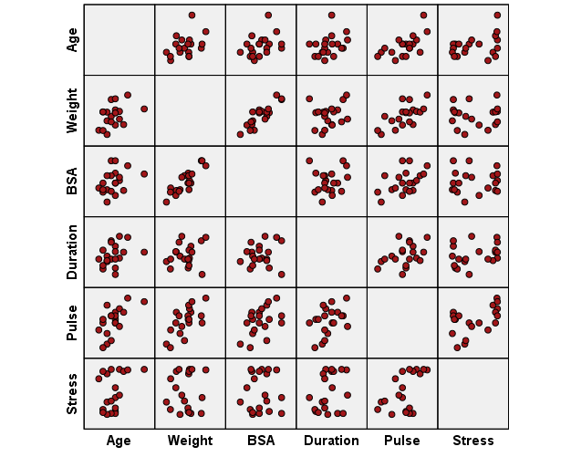

|  |  |  |  |  |  |  |  |  |
| --- | --- | --- | --- | --- | --- | --- | --- | --- |
| **Correlations** | | | | | | | | |
|  | | BP | Age | Weight | BSA | Duration | Pulse | Stress |
| Age |  | .659 |  |  |  |  |  |  |
| Weight |  | .950 | .407 |  |  |  |  |  |
| BSA |  | .866 | .378 | .875 |  |  |  |  |
| Duration |  | .293 | .344 | .201 | .131 |  |  |  |
| Pulse |  | .721 | .619 | .659 | .465 | .402 |  |  |
| Stress |  | .164 | .368 | .034 | .018 | .312 | .506 |  |

Comments:

|  |  |  |  |  |  |  |  |  |  |  |  |
| --- | --- | --- | --- | --- | --- | --- | --- | --- | --- | --- | --- |
| **Coefficientsa** | | | | | | | | | | | |
| Model | | Unstandardized Coefficients | | Standardized Coefficients | t | Sig. | Correlations | | | Collinearity Statistics | |
| B | Std. Error | Beta | Zero-order | Partial | Part | Tolerance | VIF |
| 1 | (Constant) | -12.870 | 2.557 |  | -5.034 | .000 |  |  |  |  |  |
| Age | .703 | .050 | .324 | 14.177 | .000 | .659 | .969 | .244 | .567 | 1.763 |
| Weight | .970 | .063 | .767 | 15.369 | .000 | .950 | .974 | .264 | .119 | **8.417** |
| BSA | 3.776 | 1.580 | .095 | 2.390 | .033 | .866 | .552 | .041 | .188 | **5.329** |
| Duration | .068 | .048 | .027 | 1.412 | .182 | .293 | .365 | .024 | .808 | 1.237 |
| Pulse | -.084 | .052 | -.059 | -1.637 | .126 | .721 | -.413 | -.028 | .227 | 4.414 |
| Stress | .006 | .003 | .038 | 1.633 | .126 | .164 | .413 | .028 | .545 | 1.835 |
| a. Dependent Variable: BP | | | | | | | | | | | |

Comments:

* VIF
* Correlations

|  |  |  |  |  |  |  |  |  |  |  |
| --- | --- | --- | --- | --- | --- | --- | --- | --- | --- | --- |
| **Collinearity Diagnosticsa** | | | | | | | | | | |
| Model | Dimension | Eigenvalue | Condition Index | Variance Proportions | | | | | | |
| (Constant) | Age | Weight | BSA | Duration | Pulse | Stress |
| 1 | 1 | 6.656 | 1.000 | .00 | .00 | .00 | .00 | .00 | .00 | .00 |
| 2 | .268 | 4.984 | .00 | .00 | .00 | .00 | .00 | .00 | .55 |
| 3 | .071 | 9.654 | .00 | .00 | .00 | .00 | .93 | .00 | .05 |
| 4 | .003 | 50.067 | .10 | .09 | .01 | .17 | .00 | .00 | .03 |
| 5 | .001 | 77.397 | .37 | .78 | .01 | .01 | .03 | .01 | .04 |
| 6 | .001 | 83.751 | .29 | .04 | .01 | .07 | .04 | .44 | .14 |
| 7 | .000 | **201.496** | .23 | .09 | **.98** | **.74** | .00 | .55 | .19 |
| a. Dependent Variable: BP | | | | | | | | | | |

The “Variance Proportion” shows the proportion of the variation of each regressor’s coefficient attributed to each eigenvalue. We look for regressors that have high VP on the same small eigenvalue (generally, bottom few rows), as this indicates that variances of coefficients are dependent.

Comments:

|  |  |  |  |  |  |  |  |  |  |  |  |
| --- | --- | --- | --- | --- | --- | --- | --- | --- | --- | --- | --- |
| **Coefficientsa** | | | | | | | | | | | |
| Model | | Unstandardized Coefficients | | Standardized Coefficients | t | Sig. | Correlations | | | Collinearity Statistics | |
| B | Std. Error | Beta | Zero-order | Partial | Part | Tolerance | VIF |
| 1 | (Constant) | 6.212 | 9.429 |  | .659 | .521 |  |  |  |  |  |
| Age | .563 | .206 | .259 | 2.737 | .016 | .659 | .590 | .199 | .587 | 1.703 |
| BSA | 24.554 | 3.452 | .617 | 7.114 | .000 | .866 | .885 | .516 | .700 | 1.428 |
| Duration | .077 | .204 | .030 | .376 | .713 | .293 | .100 | .027 | .808 | 1.237 |
| Pulse | .456 | .159 | .320 | 2.866 | .012 | .721 | .608 | .208 | .424 | 2.361 |
| Stress | -.017 | .013 | -.114 | -1.284 | .220 | .164 | -.325 | -.093 | .665 | 1.503 |
| a. Dependent Variable: BP | | | | | | | | | | | |

|  |  |  |  |  |  |  |  |  |  |
| --- | --- | --- | --- | --- | --- | --- | --- | --- | --- |
| **Collinearity Diagnosticsa** | | | | | | | | | |
| Model | Dimension | Eigenvalue | Condition Index | Variance Proportions | | | | | |
| (Constant) | Age | BSA | Duration | Pulse | Stress |
| 1 | 1 | 5.669 | 1.000 | .00 | .00 | .00 | .00 | .00 | .01 |
| 2 | .258 | 4.691 | .00 | .00 | .00 | .00 | .00 | .69 |
| 3 | .069 | 9.046 | .00 | .00 | .00 | .93 | .00 | .05 |
| 4 | .002 | 47.783 | .12 | .06 | .87 | .00 | .00 | .02 |
| 5 | .001 | 72.964 | .74 | .72 | .01 | .04 | .01 | .09 |
| 6 | .001 | 78.856 | .14 | .22 | .11 | .03 | .99 | .15 |
| a. Dependent Variable: BP | | | | | | | | | |

|  |  |  |  |  |  |  |  |  |  |  |  |
| --- | --- | --- | --- | --- | --- | --- | --- | --- | --- | --- | --- |
| **Coefficientsa** | | | | | | | | | | | |
| Model | | Unstandardized Coefficients | | Standardized Coefficients | t | Sig. | Correlations | | | Collinearity Statistics | |
| B | Std. Error | Beta | Zero-order | Partial | Part | Tolerance | VIF |
| 1 | (Constant) | -15.117 | 2.749 |  | -5.499 | .000 |  |  |  |  |  |
| Age | .732 | .056 | .337 | 13.154 | .000 | .659 | .962 | .262 | .603 | 1.660 |
| Weight | 1.099 | .038 | .869 | 29.093 | .000 | .950 | .992 | .579 | .443 | 2.256 |
| Duration | .064 | .056 | .025 | 1.145 | .271 | .293 | .293 | .023 | .809 | 1.236 |
| Pulse | -.137 | .054 | -.096 | -2.551 | .023 | .721 | -.563 | -.051 | .278 | 3.600 |
| Stress | .007 | .004 | .051 | 1.934 | .074 | .164 | .459 | .038 | .575 | 1.740 |
| a. Dependent Variable: BP | | | | | | | | | | | |

|  |  |  |  |  |  |  |  |  |  |
| --- | --- | --- | --- | --- | --- | --- | --- | --- | --- |
| **Collinearity Diagnosticsa** | | | | | | | | | |
| Model | Dimension | Eigenvalue | Condition Index | Variance Proportions | | | | | |
| (Constant) | Age | Weight | Duration | Pulse | Stress |
| 1 | 1 | 5.671 | 1.000 | .00 | .00 | .00 | .00 | .00 | .00 |
| 2 | .257 | 4.694 | .00 | .00 | .00 | .00 | .00 | .59 |
| 3 | .069 | 9.057 | .00 | .00 | .00 | .93 | .00 | .04 |
| 4 | .001 | 65.198 | .11 | .48 | .21 | .00 | .10 | .00 |
| 5 | .001 | 72.506 | .84 | .42 | .00 | .06 | .06 | .10 |
| 6 | .000 | 108.009 | .05 | .09 | .79 | .01 | .85 | .26 |
| a. Dependent Variable: BP | | | | | | | | | |

**Practical Week 5**

The folder **cars.sav** contains data that was collected to examine the prices of cars (*Pace New Car and Truck 1993 Buying Guide*). The variables in the data set are

**Manufacturer** name of the manufacturer

**Model** name of the model

**Type** type of vehicle (Compact, Large, Midsize, Small, Sporty, or Van)

**Price** average price of the car

**Citympg** average city miles per gallon

**EngineSize** engine displacement size (in liters)

**Horsepower** maximum horsepower

**Weight** weight of the vehicle (in pounds)

Generate a polynomial linear regression model with **LogPrice** as the dependent variable and **Citympg**, **Citympg2,** **EngineSize**, **Horsepower**, **Horsepower2**, **Weight** as the regressors. Comment on your results and see if multicollinearity is a problem for this model?